Member Profile
Name: | Steven O’Callaghan | 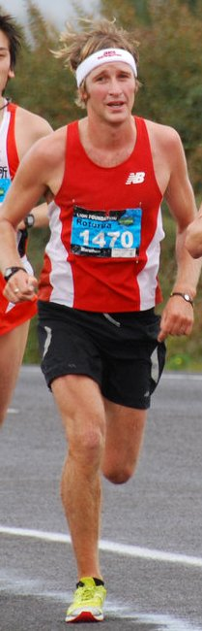
Age: | 30
Marital Status: | Married
Profession and/or place of work: | Roofer: Metalcraft Roofing
Qualifications & Experience:  (Especially if you are a Coach or Committee Member) | Club selector, ex club committee member
Events/Disciplines: | Track - Marathon
Motivation to do it: | Love it!
Own training or Coach: | Chris Sole (Dunedin) and self
Favorite training route: | Pineapple Track- Dunedin
Training, work, family -  How do fit it all in? : | I have a supportive wife. Often take my girls in the pram with me.
Favourite Pastime: | Spending time with my family.
What bits are wearing down. How many ACC visits: | You don’t won’t to know! lol
How do you handle injuries: | Try and run through them.
Secret recovery recipes: | Back off, ice, and beer.
Pre-Event Meal:
Event gear you use: | New Balance kit or else Lake city singlet
Best sporting achievement: | 2nd Rotorua and Auckland marathons, 2nd 5000m NZ champs
Most embarrassing or disastrous moment: | Falling at the finish line in Rotorua marathon 2009 after leading the whole race.
Event you’d really like to do: | Olympic marathon
Athlete you admire/why: | Steve Prefontaine because he’s the hardest man to ever run. Watch the movie!!!
Best advice to newbies: | Don’t stop. It eventually gets easier. Don’t rely on other people
Time with Lake City: | Joined in 2004
Volunteer work for the Club: | Club selector, committee member, marshall…
Suggestions for the club: | Be open to new suggestions

