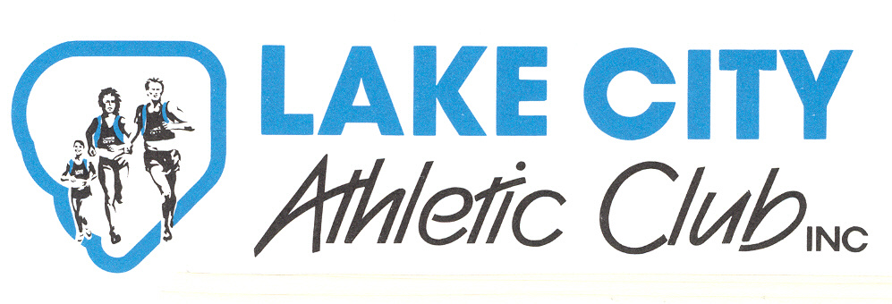
P O Box 2136, Rotorua, 3040

THE 29th ANNUAL GENERAL MEETING

of

Lake City Athletic Club Incorporated

will be held on:

Wednesday, 21st of August 2019

7.30pm

Lake City Athletic Clubrooms, Neil Hunt Park, Tarawera Road, Rotorua

AGENDA
- Apologies

- Minutes of the 28th Annual General Meeting

- President’s Report

- Presentation of Financial Statements for the year ended 31 March 2019

- Subscriptions for the 2020-2021 financial year

- Election of Officers & 8 Executive Members

- Election of Auditor

- Notice of motion to change rules to allow for payments by electronic transactions

- Life Member

- Consideration of any resolution which may have been submitted to the secretary in accordance with the Constitution and Rules.

- General Business

All completed nomination forms for Officers and Executive members of the Club must be given to the Secretary prior to the commencement of the election of officers.

John Marten
Secretary
Lake City Athletic Club
www.lakecity.co.nz
Email: info@lakecity.co.nz

